/* Write a program that starts with a line of text and then outputs that line of text with the first
occurrence of "hate" changed to "love" . For example, a possible sample output might be
The line of text to be changed is:
I hate you.
I have rephrased that line to read:
I love you.
You can assume that the word "hate" occurs in the input. If the word "hate"
occurs more than once in the line, your program will replace only the first occurrence of "hate".
Use a defined constant for the string to be changed. To make your program work for another string,
you should only need to change the definition of this defined constant. */

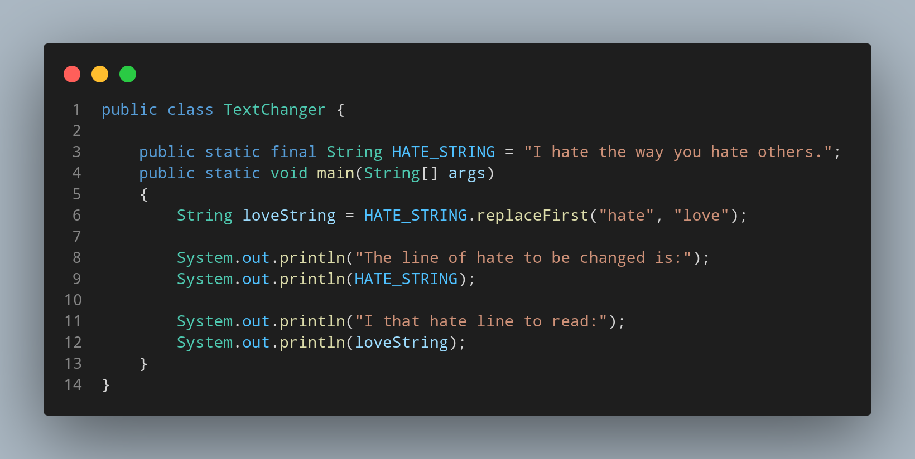

#Doc

File name TextChanger is created so we create a class name TextChanger, inside the class we created a main function. Lets create a variable storing String having hate on it.Using our replaceFirst function inside its parameter we can provide what string should replace with new string. Then we print our data as we required.

